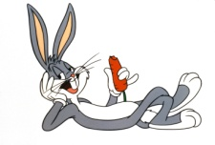 Bugs Bunny is a “trickster”. Knowing that, talk with a partner about what you think “trickster” might mean.

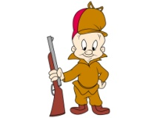Elmer Fudd is a “fool”. Knowing that, talk with a partner about what you think “fool” might mean.

Describe your team’s character. (Either Rabbit or Bear) Include his physical appearance as well as his character traits.

Do you think your character is the trickster or the fool? Support your choice with evidence from the text.

 Bugs Bunny is a “trickster”. Knowing that, talk with a partner about what you think “trickster” might mean.

Elmer Fudd is a “fool”. Knowing that, talk with a partner about what you think “fool” might mean.

Describe your team’s character. (Either Rabbit or Bear) Include his physical appearance as well as his character traits.

Do you think your character is the trickster or the fool? Support your choice with evidence from the text.